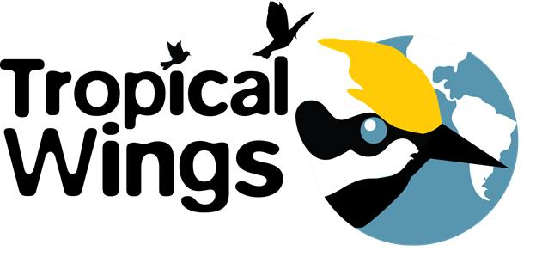
Tropical Wings, Inc.
2019 Habitat Restoration Grant Application

Tropical Wings, Inc., will award grants of up to $1000 to individuals, businesses and organizations in the St. Croix River Watershed to preserve and restore migratory bird habitat. If you are interested in applying please complete and return the following by March 15, 2019. Projects will be selected by April 15, and we ask selected projects to send a representative to our Bird Celebration Friday evening May 10th at the Phipps Center for the Arts in Hudson, WI to formally receive your funds. We also ask for a representative to attend our annual meeting in the fall to display a tri-fold poster board and answer questions from annual meeting attendees.

Grants will be awarded based on efforts that directly benefit migratory birds and their habitat. Please return the grant application to:

info@tropicalwings.org OR mail to Tropical Wings, Inc., 2107 Chestnut Dr., Hudson, Wisconsin, 54016

Organization Name:
Contact Name:
Mailing Address:
Phone Number:
Email:

Brief (maximum 2 sentences) statement describing your project:

Narrative: (please write a brief narrative – 300 words or less – on how you would use the funds, why it is important and the impact you hope to achieve for migratory bird habitat)

Information about Tropical Wings, Inc., can be found on our website, tropicalwings.org

